1. Briefly explain the function and the role of the following devices:
2. Repeater
3. Bridge
4. Hub
5. Switch
6. Router

**Part 1**

* **What is IP address?**
* **What are the different classes of IP addresses and give the range of each class?**
* **What is subnet mask?**
* **What is the LOOPBACK address?**
* **What is a Default Gateway?**
* **Difference between public and private IP addresses?**
* **What is IANA?**
* **What is DHCP?**
* **What is 127.0.0.1?**
* **What is ‘APIPA’?**
* **Explain the difference between Static and Dynamic IP?**
* What is subnetting and what are the advantages of it, why use it? Explain with examples.

**Part 2:**

**Exercises:**

1. Assuming these are classful IP addresses, determine the default subnet mask, network address and broadcast address for each of them.
2. 192.132.5.4
3. 129.43.50.7
4. 117.12.4.3
5. 25.34.3.8
6. 150.168.62.10
7. 205.42.34.18
8. If you have a subnet mask of 255.255.255.240 how many bits did you borrow and how many Subnets do you have?

a)   borrowed 3 bits and have 6 subnets

b)   borrowed 4 bits and have 6 subnets

c) borrowed 4 bits and have 16 subnets

d) borrowed 2 bits and have 4 subnets

1. You need 3 subnets.  How many bits would you borrow and what would be the subnet mask?

a) borrow 3 bits and SM 255.255.255.224

b) borrow 3 bits and SM 255.255.255.240

c) borrow 2 bits and SM 255.255.255.192

d) borrow 4 bits and SM 255.255.255.240

1. You need to have 10 hosts per subnet.  How many bits will you borrow and what is the subnet mask?
2. borrow 2 bits and SM 255.255.255.192
3. borrow 3 bits and SM 255.255.255.224
4. borrow 4 bits and SM 255.255.255.240
5. borrow 5 bits and SM 255.255.255.248
6. You have a class C network address divided into 3 subnets, you will add 2 subnets in the next 2 years each subnet will have 25 hosts. What subnet mask should you use?
   1. 255.255.255.192
   2. 255.255.255.0
   3. 255.255.255.248
   4. 255.255.255.224
   5. none of the above
7. You have been hired as a consultant to plan a TCP/IP network for a company that has the network address of 216.176.255.0 You determine that the network will need nine subnets. Which subnet mask will provide the highest number of hosts per subnet?

a) 255.255.255.240

b) 255.255.255.224

c) 255.255.255.248

d) 255.255.255.192

1. You have a network ID of 140.140.0.0 and need to break it down into a number of subnets. You need 600 host IDs per subnet, with the largest number of subnets available. Which of the following subnet masks should you use?

a) 255.255.240.0

b) 255.255.252.0

c) 255.255.224.0

d) 255.255.248.0

1. You are assigned an IP address of 172.30.0.0 and you need 55 subnets, how many hosts do you have per subnet?
2. You are assigned an IP address of 172.30.0.0 and you need 1000 hosts on your network, what is your subnet mask?
3. How many subnets and hosts per subnet can you get from the network 172.21.0.0/21?
4. How many subnets and hosts per subnet can you get from the network 172.19.0.0 and subnet mask 255.255.255.0?
5. For each of the IP address listed, identify the following:

* No of subnets
* No of hosts
* Subnet Mask
* Network address
* Broadcast address
* Range of usable IP

1. 191.32.5.4/29
2. 197.12.4.3/25
3. 205.34.3.8/30
4. 210.168.62.10/27
5. 194.25.128.36/26
6. 218.12.254.98/28
7. 220.134.23.9/25
8. 152.148.20.5/19
9. 132.18.35.3/22
10. Create and configure two segments in a LAN using packet tracer.You are given two switches(Labelled as Switch 0 and Switch 1)and two computers(Labelled as PC0 and PC1).While creating two different segments in a LAN,the following points should be taken care of.

* Use generic desktop and generic switch for this network
* Use Copper straight-through cable for connecting PCs to Switches
* Use PC0’s FastEthernet0 port to connect to Switch0’s FastEthernet0/1
* Use PC1’s FastEthernet0 port to connect to Switch1’s FastEthernet0/1
* Set the IP address 192.168.1.1 for PC0
* Set the IP address 192.168.1.2 for PC1
* Verfiy the operation of the network by pinging from PC 0 to PC 1

1. Using Packet Tracer design the following network and verify the network using ping command.

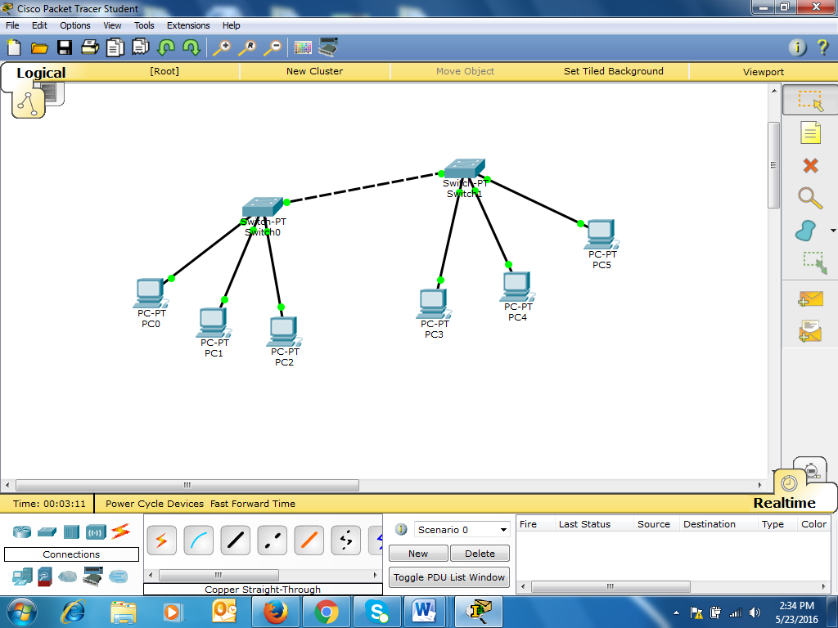

Set IP Address 192.168.1.2 for PC0

Set IP Address 192.168.1.3 for PC1

Set IP Address 192.168.1.4 for PC2

Set IP Address 192.168.1.5 for PC3

Set IP Address 192.168.1.6 for PC4

Set IP Address 192.168.1.7 for PC5

1. Using Packet Tracer design the following network and verify the network using ping command.

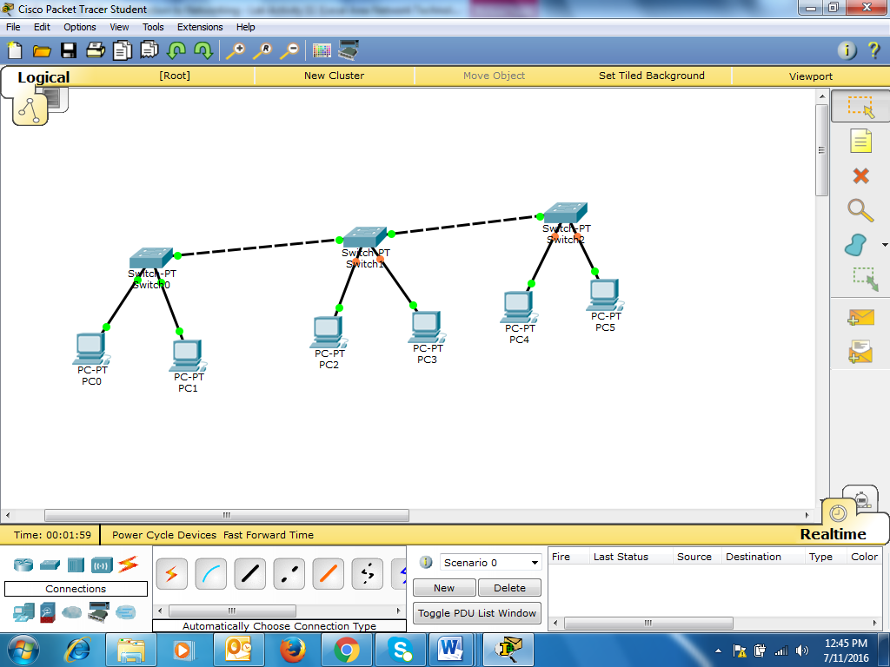

Set IP Address 192.168.2.1 for PC0

Set IP Address 192.168.2.2 for PC1

Set IP Address 192.168.2.3 for PC2

Set IP Address 192.168.2.5 for PC3

Set IP Address 192.168.2.6 for PC4

Set IP Address 192.168.2.7 for PC5

**Practical: Using Packet Tracer**

1. Make sure Cisco Packet Tracer software is installed in your PC
2. Verify the network by using ping command.

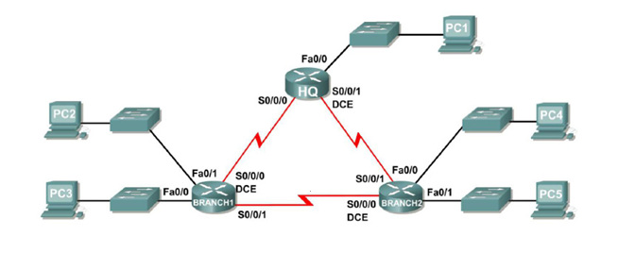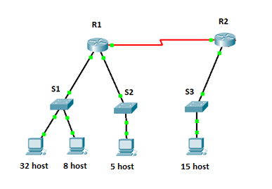

**200.168.30.0**

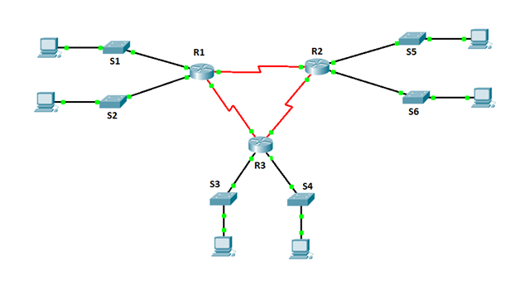

**203.30.60.0**